**Angle 36, Speed 10**

Result Log for stopping experiment with accuracy at cycleAccuracy 0.7333333333333334

reaching stable after enter newborn cycle 330.

Elapsed time: 4 min.

circle reach average Accuracy 0.8

rectangle reach average Accuracy 0.5714285714285714

triangle reach average Accuracy 0.8285714285714286

Stop SP+TM after 9 cycles

Elapsed time: 3 min.

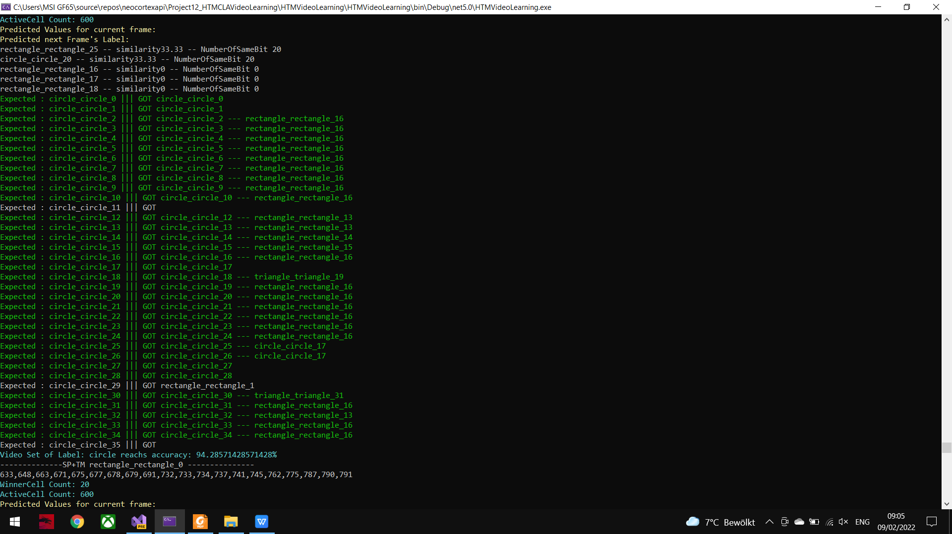

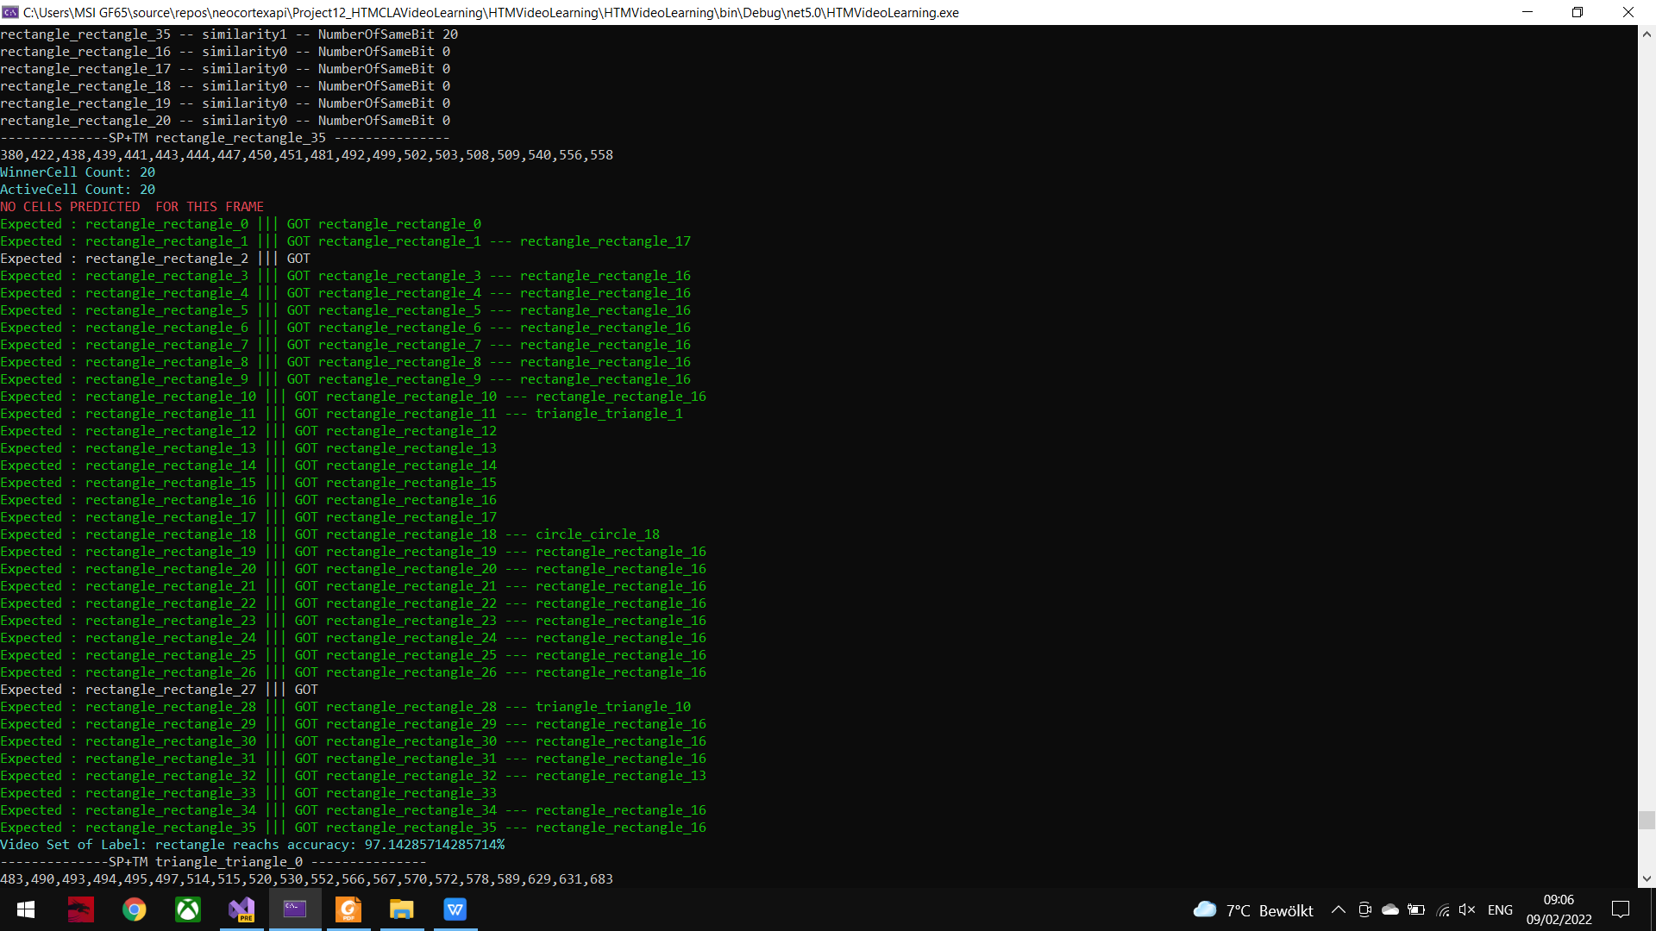

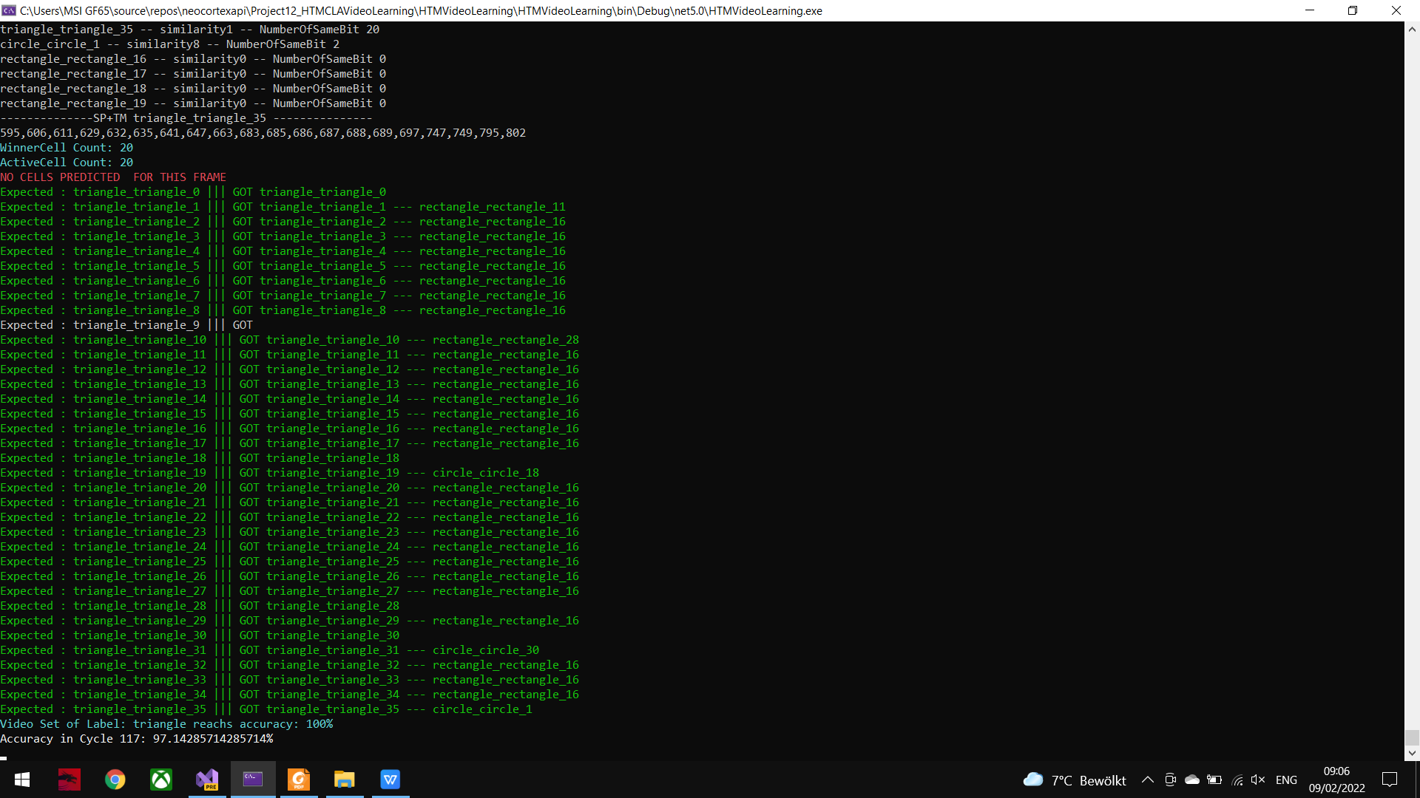

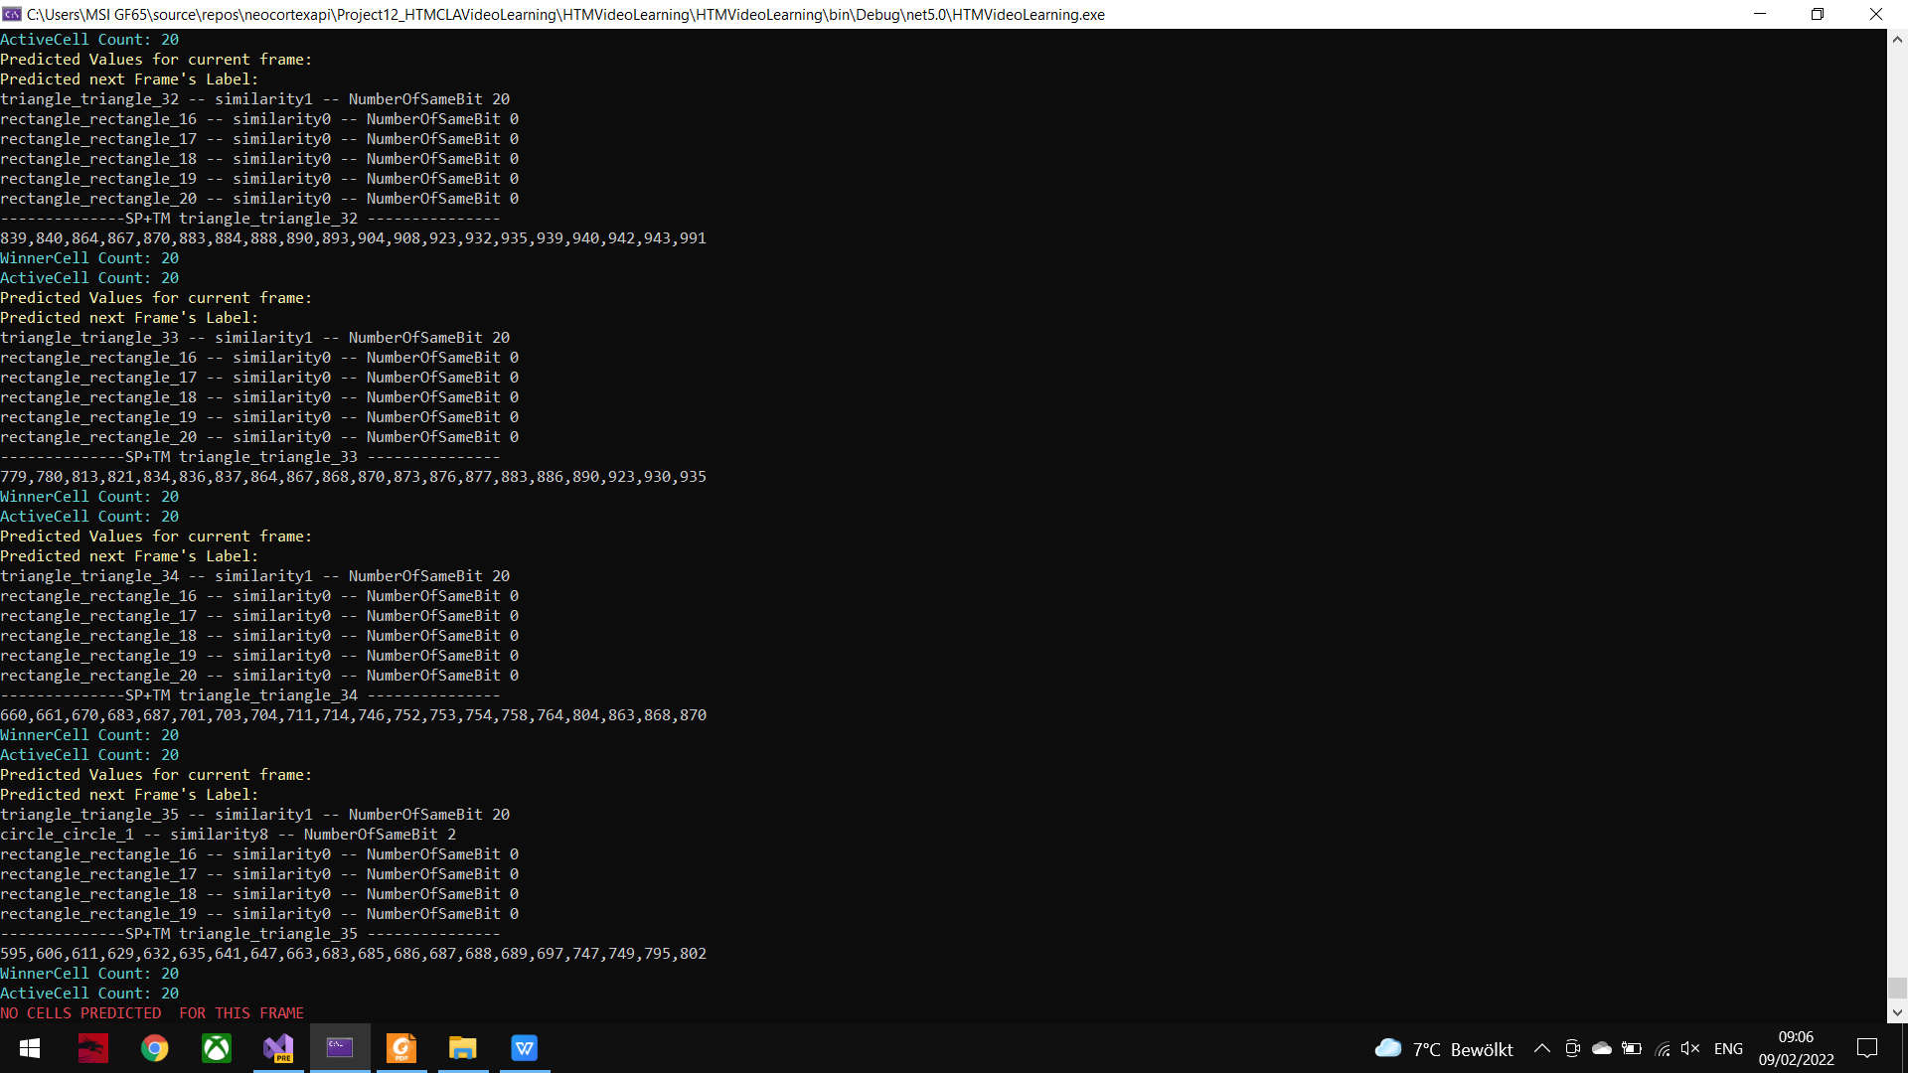

**Angle 72, Speed 10**

Result Log for stopping experiment with accuracy at cycleAccuracy 0.6095238095238095

reaching stable after enter newborn cycle 295.

Elapsed time: 3 min.

circle reach average Accuracy 0.37142857142857144

rectangle reach average Accuracy 0.5714285714285714

triangle reach average Accuracy 0.8857142857142857

Stop SP+TM after 9 cycles

Elapsed time: 2 min.

**Angle 108, Speed 10:**

Result Log for stopping experiment with accuracy at cycleAccuracy 0.7333333333333333

reaching stable after enter newborn cycle 294.

Elapsed time: 4 min.

circle reach average Accuracy 0.5142857142857142

rectangle reach average Accuracy 0.7714285714285715

triangle reach average Accuracy 0.9142857142857143

Stop SP+TM after 9 cycles

Elapsed time: 3 min.

**Angle 144, Speed 10:**

Result Log for stopping experiment with accuracy at cycleAccuracy 0.7523809523809524

reaching stable after enter newborn cycle 237.

Elapsed time: 3 min.

circle reach average Accuracy 0.8285714285714286

rectangle reach average Accuracy 0.5428571428571428

triangle reach average Accuracy 0.8857142857142857

Stop SP+TM after 9 cycles

Elapsed time: 3 min.

**Angle 180, Speed 10: This specific angle requires longer run time than others**

Result Log for stopping experiment with accuracy at cycleAccuracy 0.638095238095238

reaching stable after enter newborn cycle 162.

Elapsed time: 11 min.

circle reach average Accuracy 0.6571428571428571

rectangle reach average Accuracy 0.4857142857142857

triangle reach average Accuracy 0.7714285714285715

Stop SP+TM after 9 cycles

Elapsed time: 4 min.

**Angle 216, Speed 10:**

Result Log for stopping experiment with accuracy at cycleAccuracy 0.6

reaching stable after enter newborn cycle 276.

Elapsed time: 2 min.

circle reach average Accuracy 0.6571428571428571

rectangle reach average Accuracy 0.4857142857142857

triangle reach average Accuracy 0.6571428571428571

Stop SP+TM after 9 cycles

Elapsed time: 3 min.

**Angle 252, Speed 10:**

Result Log for stopping experiment with accuracy at cycleAccuracy 0.6952380952380953

reaching stable after enter newborn cycle 267.

Elapsed time: 2 min.

circle reach average Accuracy 0.7142857142857143

rectangle reach average Accuracy 0.7142857142857143

triangle reach average Accuracy 0.6571428571428571

Stop SP+TM after 9 cycles

Elapsed time: 4 min.

**Angle 288, Speed 10:**

Result Log for stopping experiment with accuracy at cycleAccuracy 0.6952380952380953

reaching stable after enter newborn cycle 289.

Elapsed time: 2 min.

circle reach average Accuracy 0.6857142857142857

rectangle reach average Accuracy 0.7714285714285715

triangle reach average Accuracy 0.6285714285714286

Stop SP+TM after 9 cycles

Elapsed time: 4 min.

**Angle 324, Speed 10:**

Result Log for stopping experiment with accuracy at cycleAccuracy 0.6476190476190476

reaching stable after enter newborn cycle 298.

Elapsed time: 3 min.

circle reach average Accuracy 0.7714285714285715

rectangle reach average Accuracy 0.42857142857142855

triangle reach average Accuracy 0.7428571428571429

Stop SP+TM after 9 cycles

Elapsed time: 4 min.

**Angle 360, Speed 10:**

Result Log for stopping experiment with accuracy at cycleAccuracy 0.6095238095238095

reaching stable after enter newborn cycle 163.

Elapsed time: 12 min.

circle reach average Accuracy 0.4

rectangle reach average Accuracy 0.6285714285714286

triangle reach average Accuracy 0.8

Stop SP+TM after 9 cycles

Elapsed time: 5 min.